Assignment 2 sql

Qn 1 Start by returning all rows and columns from the hero_battles data table.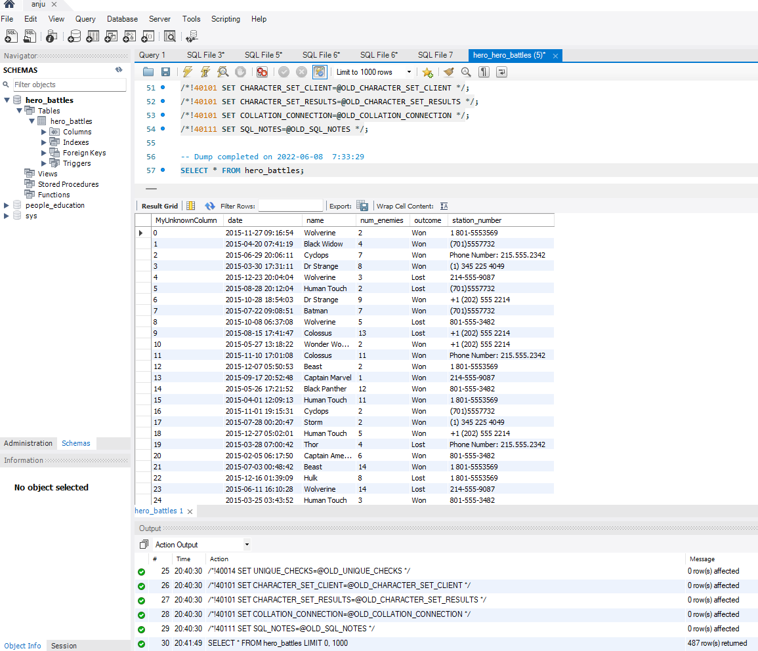

Qn 2 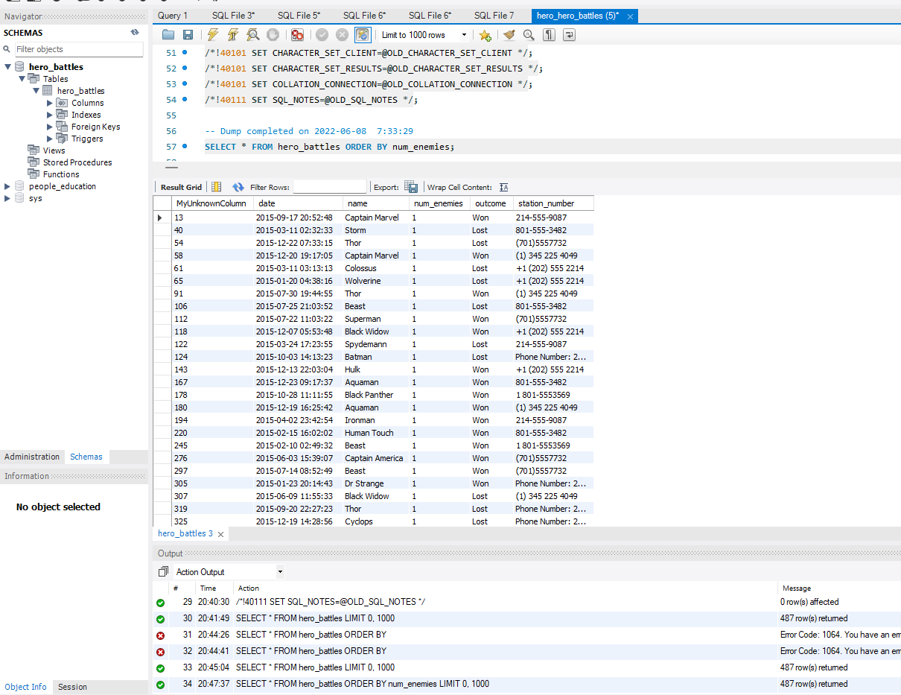

Qn3 Take that same query but change it and sort descending instead.

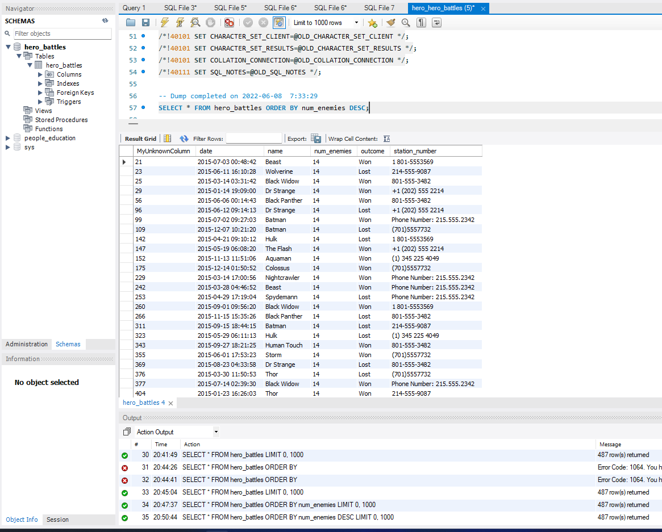

Qn4 Great work! Keep the current query, but only show rows where the name column is equal to Batman

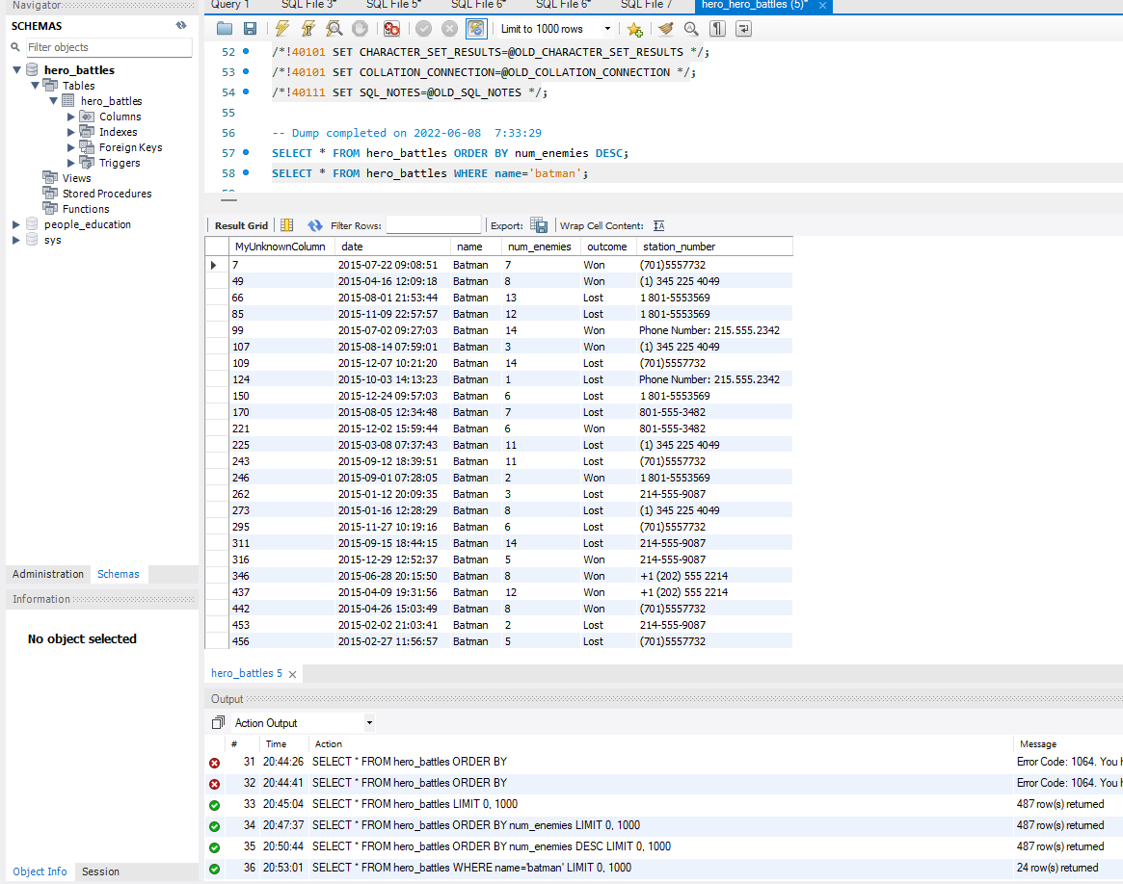

Qn 5 Next, edit the prior query to return the result set that is not Batman.

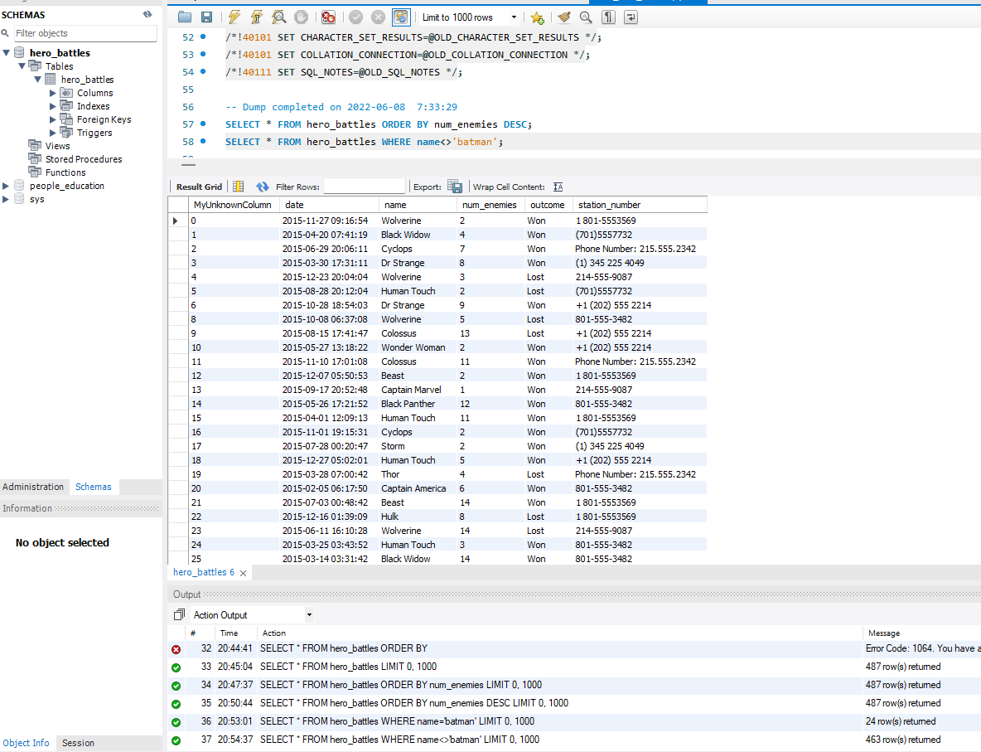

Qn 6 Write a query that returns a data set that contains all the data where the number of enemies fought was 1 or 2.

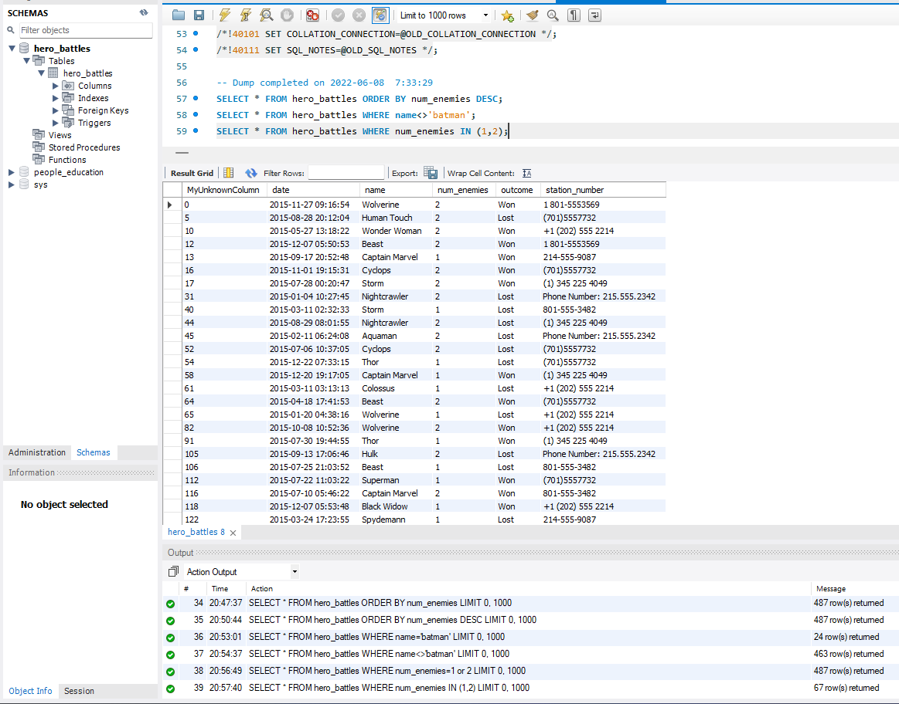

QN7Now take that and write a query with all the data where the number of enemies was 1, or 2, or 10, or 12. Use an IN clause.

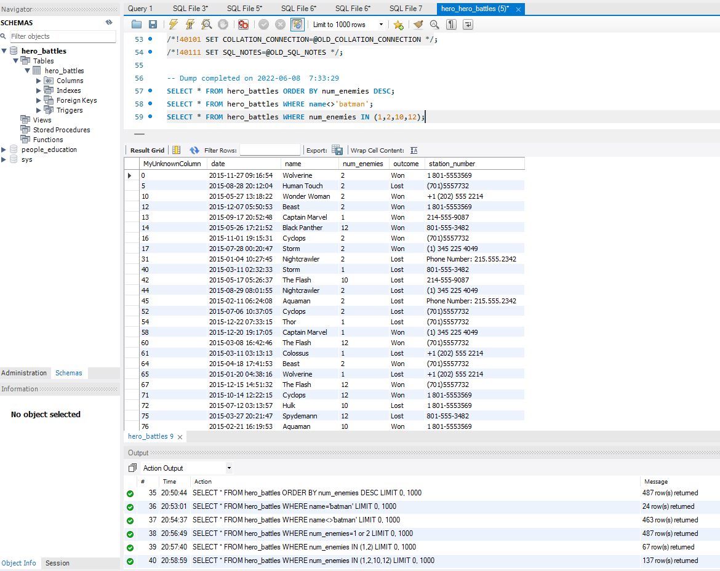

QN8 Make a new query that returns any row where the name column contains the phrase “man”.

